Eastern Woodland Art Symbolism

The Meaning of the Symbols
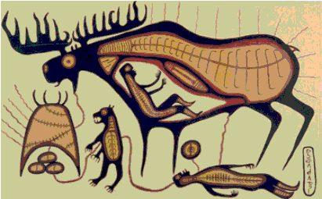
When Norval Morrisseau first began painting, his intention was to re-introduce the Anishnaabe world view into the contemporary consciousness. The Ojibwa culture had been all but obliterated by the imposition of external governance and the influence of christian churches.
Using primary colours straight out of the tubes, Morrisseau painted the spiritual reality that had been the foundation of Ojibwa life for thousands of years. Raised by his shaman grandfather, Norval was familiar with the symbols used on the midewiwin birch bark scrolls. He knew the legends and he was intimately familiar with the ochre images that were everywhere on the rock faces that bordered the waterways surrounding his home.
Woodland art symbolism permeated his early paintings. The following may help you understand why he incorporated certain things into his imagery.
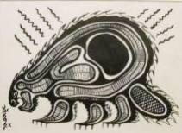
- Lines of Power
Woodland art often shows lines of power radiating from the heads and bodies of both animals and people. The lines are usually short but the variations in length and intensity indicate the quality of power. The lines can both transmit and receive information.
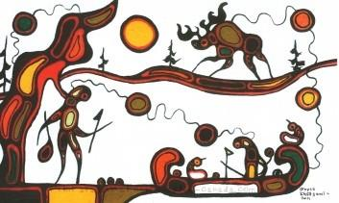

- Lines of Communication
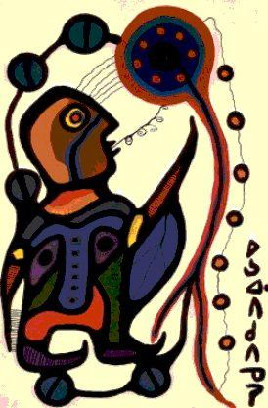
Woodland artists often portray animals and people joined with flowing lines which indicate relationships which reflect the artist's understanding of the nature of the interdependence between the two beings. This is a recent painting by Goyce Kakegamic depicting the legend of Red Lake.
- Lines of Prophecy
Some powerful creatures may have narrow ivy-like lines spewing from their mouths which indicate more than simple speech - they indicate prophecy, particularly in association with shaman imagery. A good example is this painting by Norval Morrisseau showing a shaman making direct communication with the universal life force.

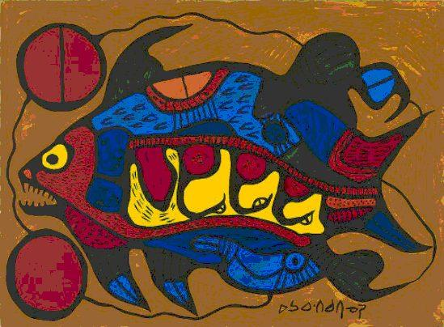
- Lines of Movement
Very short lines, clustered near an organ like a heart as in this example, indicate movement and an active attempt at communication with the viewer. The lines are particularly significant surrounding shaking tent imagery.

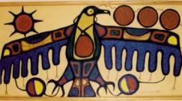
- The Divided Circle
A circle divided in half, connected with the main image by lines of communication is an especially meaningful symbol used by woodland artists. The divided circle represents dualities present in the world - good and evil, day and night, sky and earth, honest and dishonest, function and dysfunction for example.
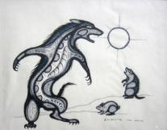
- X-Ray Decoration
The term would have been meaningless to prehistoric woodland artists, but nowadays the concept of an x-ray view aptly describes the way woodland artists depict inner structures of people and animals. They are representations of inner spiritual life.

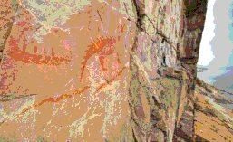
- Colour
In prehistoric times the only significant colour used was red ochre as in this ancient image of mishpashu (a water spirit) on a cliff overlooking Lake Superior. In 1937 the image had been covered over with dark green oil based house paint by the twelve year old daughter of the local Indian agent. More than seventy years later the green paint has been destroyed by the elements but the original ochre illustration still stands proud.

