Eastern Woodland Painting
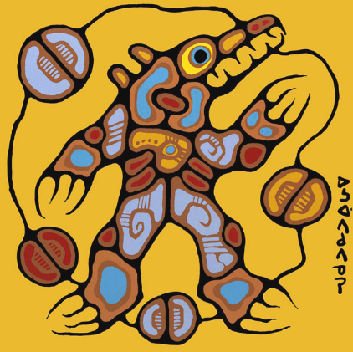
Eastern Woodland Painting usually has…

- people and/or animals as the main subject
- often look like x-rays to show both the interior and exterior life of the organism
- a background, usually painted in one or two large areas of flat, bright colour
- simple shapes outlined in thick black & filled with bright colours that reflect the mood of the painting
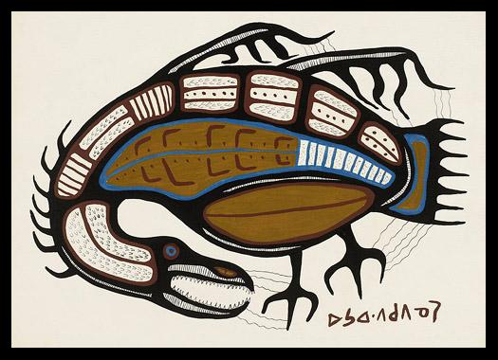
- symbols (pictures that tell a story without using words)
- no sense of place (no landscape or horizon line)
- no shading or textures; single values used

Symbolism in Eastern Woodland Painting

Examples of symbols in Morrisseau’s work are:
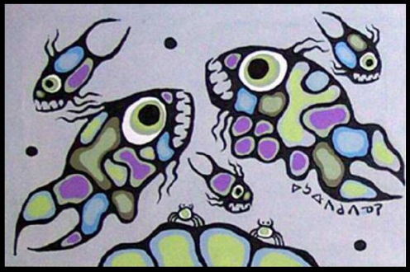
- large eyes – the symbol of the shaman or person who can interact with the spirit world
- the divided circle – shows dualities in the world like good and evil, day and night, sky and earth, honesty and dishonesty
- several different kinds of lines:
- lines of power radiate out from the head and/or body
- communication lines connect creatures and show interdependence of two beings and their relationships in nature
- small movement lines in and around a body can show shaking, for example, or a heart beating
- solid balls or seeds represent spirit power, often float within the picture
- circles – sacred to First Nations spirituality; the life cycle, the sun, the moon, and the directions (north, south, east, west)
