Eastern Woodland Painting Project Outline

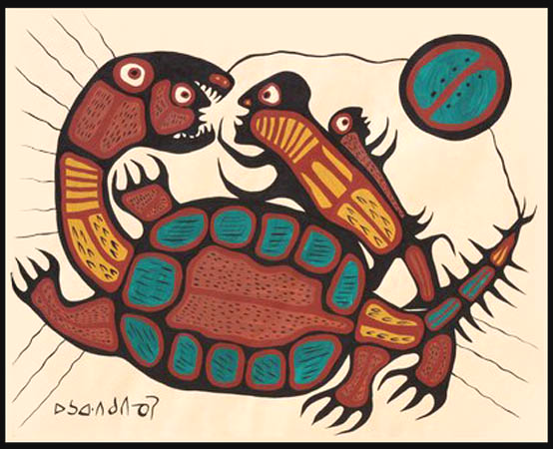
Unit Objectives:
  - Create a painting in the Eastern Woodland style based on your own design depicting your experience with a Canadian animal
  - Paint with acrylic paints
  - Understand the use and care of all related materials and how to do proper clean up

Step 1: Brainstorming
Jot down your answers to the questions below on a page in your sketchbook. This will help you develop an idea for your painting
- What is a special or memorable experience you have had with nature and/or wildlife in Canada?
- Is there a story or legend or belief you have about a particular animal or some aspect of nature from your culture? Do you have a spiritual connection to a particular animal or to an animal from your culture?
- Do you love a particular Canadian animal or feel a special connection to an animal? Do you think a certain animal resembles aspects of your character or personality? Are you a “loner” like a moose? Are you a “pack animal” like a wolf? Do you “go against the flow” like a salmon? Think about why and what it means to you.
- What does your animal symbolize? See the handout “First Nation Animal Symbols”

Step 2: Sketch your animal
- Find photographs of your animals taken from angles that are suitable to your design. (Do not draw from drawings please - this has got to be YOUR artwork, not a copy of someone else's!!)
- Do a minimum of 2 contour drawings of the animal in your sketchbook (different poses).
- Don't make the drawings too small - fill the page. Because the style of Woodland Painting is based on shapes, look carefully at the shapes you see in the animals' forms.
- Accuracy matters: Proportion, shape, details...Make your drawings as accurate as you can - remember contour drawing techniques which will increase your observation and decrease your generalisations so your sketches become more life like.

Step 3: Create a design (or possible designs) for your painting:
- Don’t be afraid to do two or three versions. Think about the elements and principles of design.
  - Looking at the refernce sheet, add details and symbols that Morrisseau and the other Eastern Woodland artists used.
  - Use a Sharpie to outline the lines (remember to vary the thickness of the lines - they might even merge into solid shapes - example, around the face)
  - Have your final design enlarged (photocopied)

Step 4: Choose a colour scheme:
  - Decide on a colour scheme - monochromatic, split complementary, analogous, warm or cool
  - Find 3 colour swatches from magazines. Cut out the colour swatches and glue beside your design. You need a colour swatch for:
- the background
- 2 main colours for the animal
  - Use your colour pencils to plan out the other colours on your rough design
When this step is done, submit to teacher. Once design and colour scheme are approved, start the good copy.

Step 5: Create your painting:
  - Mix the background colour and paint the entire canvas
  - Use the tracing process to transfer the design onto the canvas (or draw freehand)
  - Outline the design using black
  - Paint using colours that you have mixed. Only white and black can be used from the jars - everything else must be mixed by you!!!!)
  - When finished, touch up the black outlines
  - Include a black border around the edge if you wish (use painters tape to mask the area in order to create a sharp black edge)

Step 6: Reflection. Complete the reflection sheet about your painting and the process of creating it.

