NORVAL MORRISSEAU

“X-RAY PAINTING”
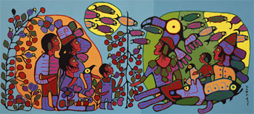
Norval Morrisseau: Observation of the Astral World (1990)
Source: National Gallery of Canada and CyberMuse
http://national.gallery.ca

Background:
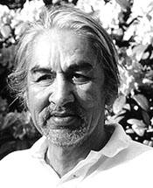
Norval Morrisseau was born in the early 1930s on the Sandy Point Lake Reserve north of Thunder Bay in Ontario Canada.
He was raised by his Grandparents and through them learned traditional Ojibwa customs, values and beliefs. It was in his youth that he received - from his Grandfather - his "mission" to share through art, all of those things he was taught to respect about Ojibwa culture.
During the 1950s, Morrisseau was hospitalized with Tuberculosis. While in hospital, he began painting and drawing his visions on birch bark and brown paper bags... he painted visions which were uniquely his own. Later, in the 1960s he traveled widely to bush communities in Canada and visited some northern Minnesota reservations where he met with many who today are considered knowledgeable elders, both to learn from them and to teach. He taught by painting, as well as writing.
A medicine man or shaman, Morrisseau developed a style which has since evolved and been used by many Native artists. The style is called the Eastern Woodland Style and can be seen in the works of Daphne Odjig, Carl Ray and Blake Debassige.

Norval Morrisseau
1931 - 2007
Norval Morrisseau is one of the most original and important artists, native or otherwise that Canada has produced. Norval was the first to paint the ancient myths and legends of the eastern woodlands, stories previously passed down by the oral tradition. He spent his youth in remote isolation in northern Ontario, near Thunderbay, where his artistic style developed without the usual influences of other artist's imagery. As the sole originator of his "Woodland" style he has become an inspiration to three generations of artists.
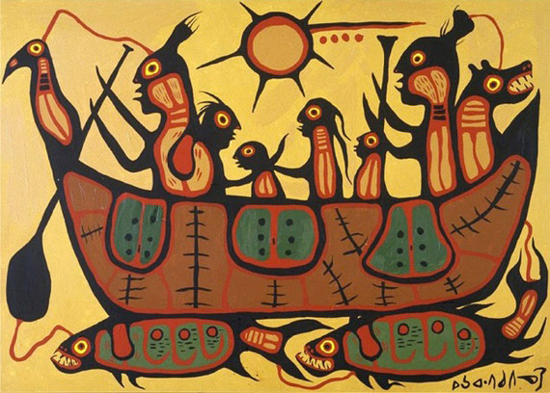
Norval was brought up by his grandfather who introduced him to Ojibwa shamanism and told him the stories and legends passed down amongst the Ojibwa people. Norval began producing images to illustrate these stories. He would draw on the sandy beaches of Lake Nippigon with a stick and let the waves take the images away. He was told by some that it was taboo to relate these stories.

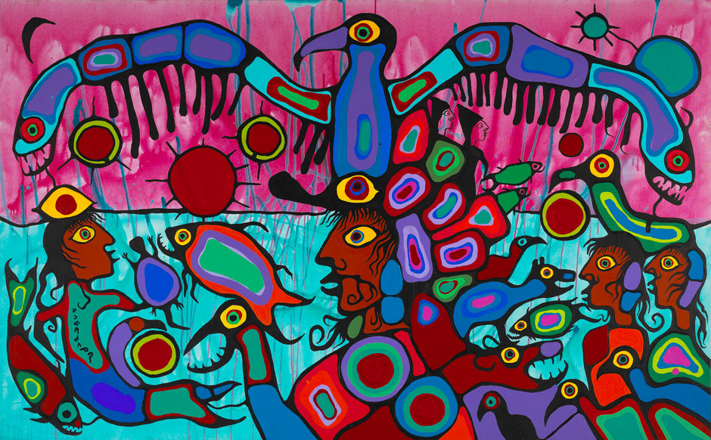
Norval Morrisseau is not a man that is easily dissuaded by ancient taboos. He developed his style, adding striking color to his paintings and eventually took them south to Toronto where they were met with rave reviews. His work now hangs in all of the most prestigious museums in Canada and around the world. He has received an honorary degree from the Royal Academy of Arts and is a member of The Order Of Canada, the highest civilian honor in Canada. He has had numerous solo shows across Canada and the US.

His work invokes our memories of childlike simplicity. His colors affect us in ways that are not immediately apparent. His visions, like ancient taboos that have turned into dreams of the future, come to life on canvas and paper. They are talismans of the future and images of respect of the past.

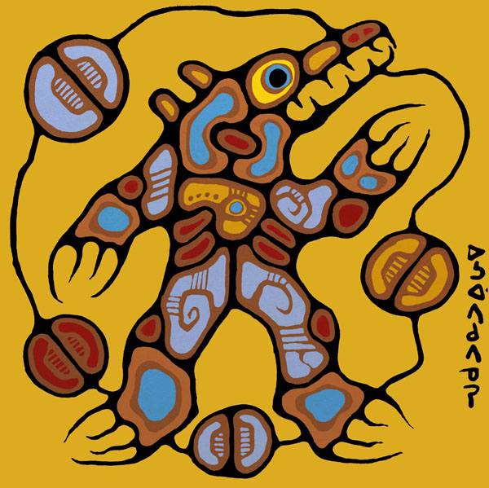
"Medicine Bear" - "The Ojibwa have great respect for the Bear. According to their legends, in the distant past the Bear had a human form and was in fact an ancestor of the Ojibwa. Therefore he understands the Indian language and will never attack or fight any Indian if he is addressed properly." - Norval Morrisseau

Vocabulary:
Image - An image is essentially a picture ... something seen in a work of art. In Morrisseau's work, we see images of people and animals.
Ground - This is what the artist has created his work on ... this could be birch bark, paper, canvas or wood.
Media or Medium - This is what the artist uses to create his/her work. Paint (tempera, acrylic, watercolor, oil), pencil, crayon, conte chalk ... all are known as media.
Symbol - A symbol is a picture or image that tells a story without using words. Ask your students to think about "everyday" symbols like the pictures seen on men's and ladies washrooms, no smoking signs or the Big "M" of McDonalds. How many other symbols can you think of?
Some examples of Symbols in Morrisseau's work:
Circle - The circles in Morrisseau's work tell us about the life cycle, the sun, the moon and directions (North, South, East, West).
LinesEnergy Lines. You can see them extending from the hand or the body of a figure. Sometimes they are connected ... sometimes they are alone or isolated.
Eyes - Large eyes that see all can be found in Morrisseau's work. These eyes are a symbol of a shaman or medicine man.
X-Ray - This is a style attributed to Morrisseau. The X-Ray technique shows the interior as well as the exterior of a figure. The various parts of a body for example are expressed with different colors and lines

